**Team E**

**Members:**

**Prajwal**

**Pradul**

**Gayathry**

**Pramitha**

**LINUX COMMANDS & TROUBLESHOOTING**

1. Command: tar -cvf ustnew.tar /home/ubuntu/Desktop/newust  
    This command was run to unzip a tar file.

Error Image:

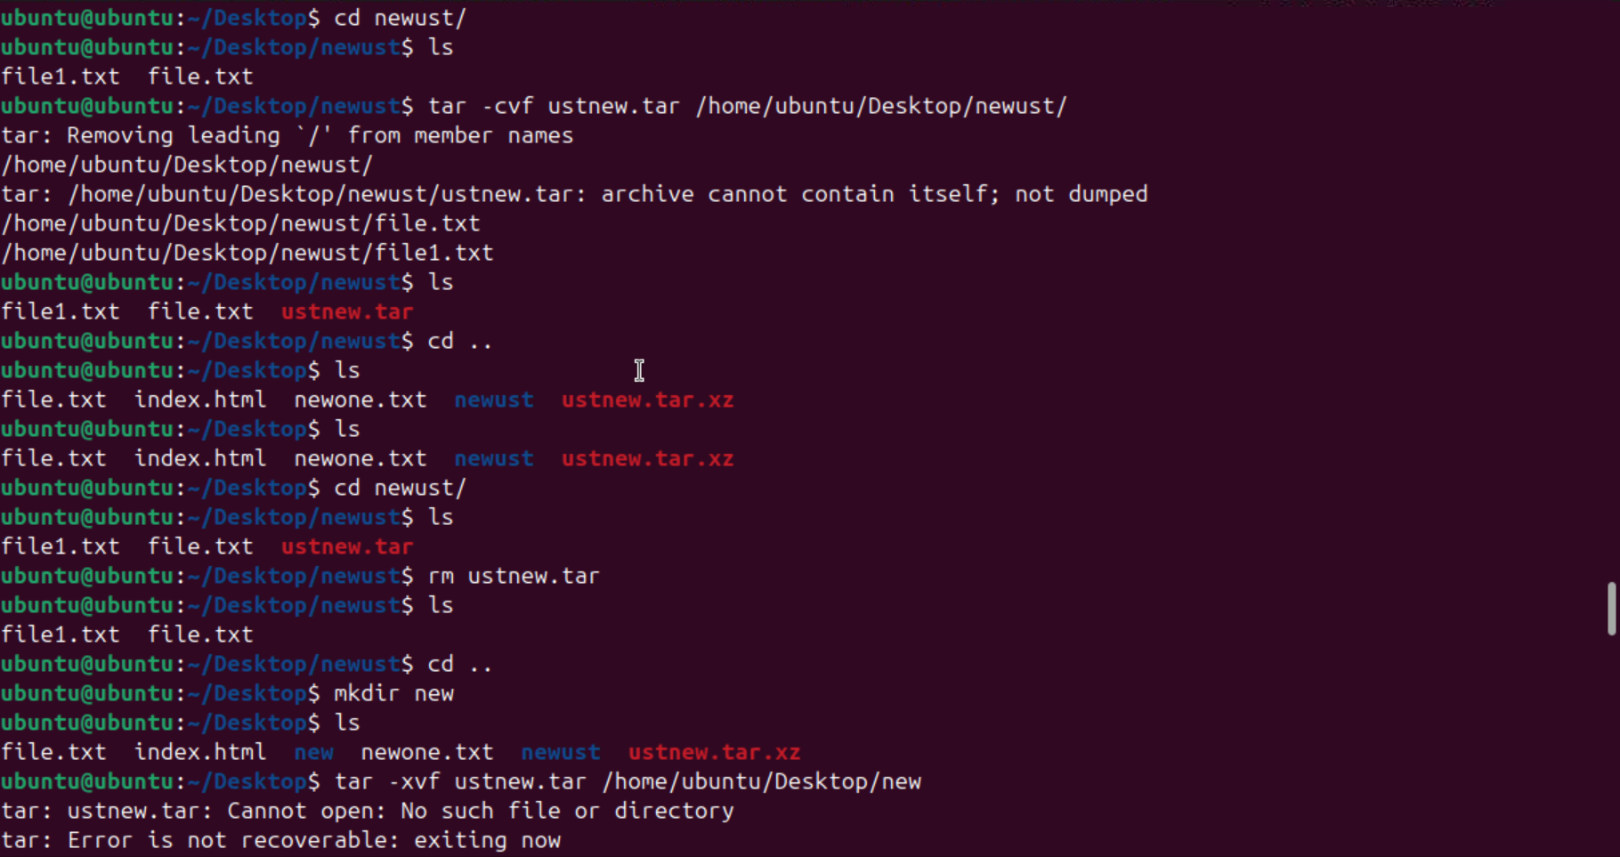

The error here occurred is because of the trailing ‘/’ and because of the incomplete tar file names.

**Troubleshoot:**

Command: tar -xvf ustnew.tar.xz /home/desktop

1. Command: command -help

This command helps to display short summary information.

Error Image:

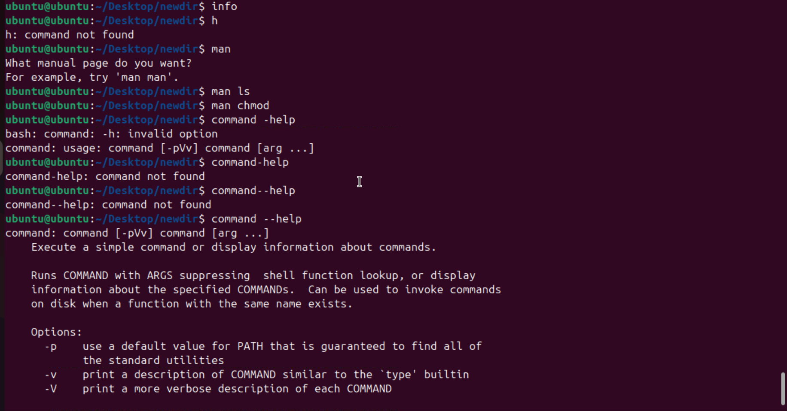

Command help was not found due to single hyphen used and second time the error was due to no space between the command and hyphen keyword.

**Troubleshoot:**

Troubleshoot the issue by inputting a hyphen extra between command and help.

Command: command –help

1. Command: rmdir ust

This command helps to remove directory

Error image:

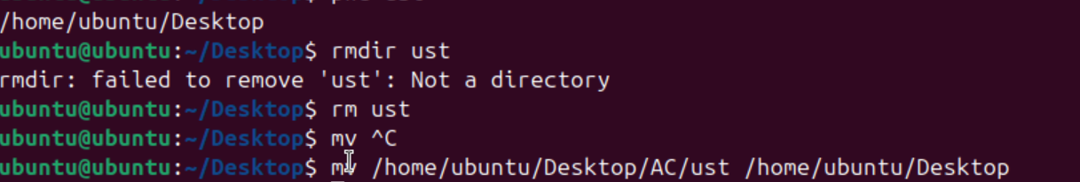

**Troubleshooting:**

rmdir can only remove the directory, if you want to remove file use rm filename.

1. Command: wget

Wget used to install any Linux files through http address.

Error Image:

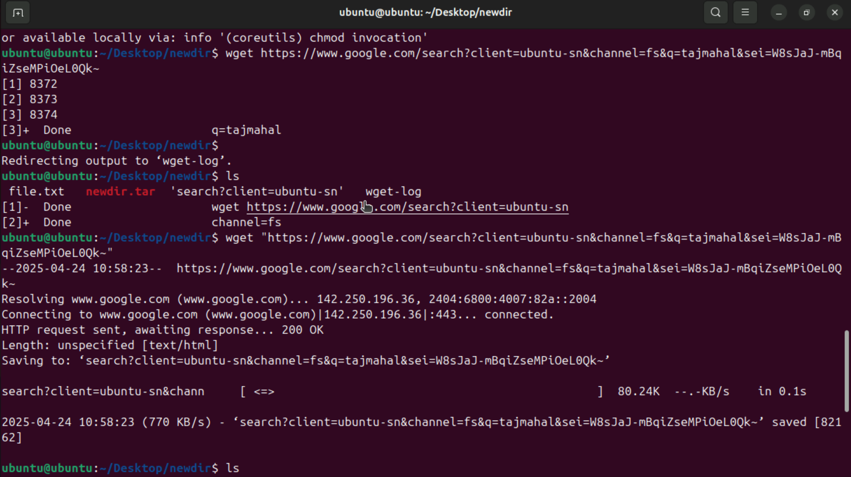

Error occured here due to absence of  double quotes.

**Troubleshooting:**

Troubleshoot by giving proper http address inside the double quotes.

Command: wget “example_link”

1. Command; gedit eg_filename

This commands opens the file for editing.

Error Image:

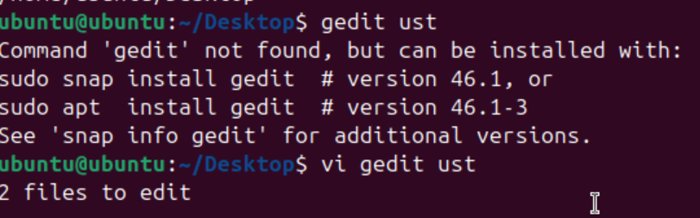

Gedit not working

**Troubleshooting:**

Install gedit.

Command: install gedit - sudo apt install gedit

1. Command: grep -i “H” ust.txt

To search and see through all the text files.

Error Image:

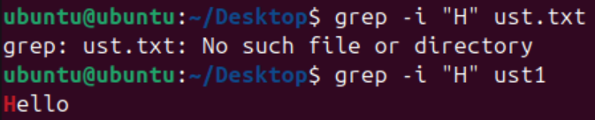

No such file or directory.

**Troubleshooting:**

No need to add the extension of the file name.

Command: grep -i “H” ust1

1. Command: locate pattern

Locate pattern is used to  Search and print files and folders.

Error Image:

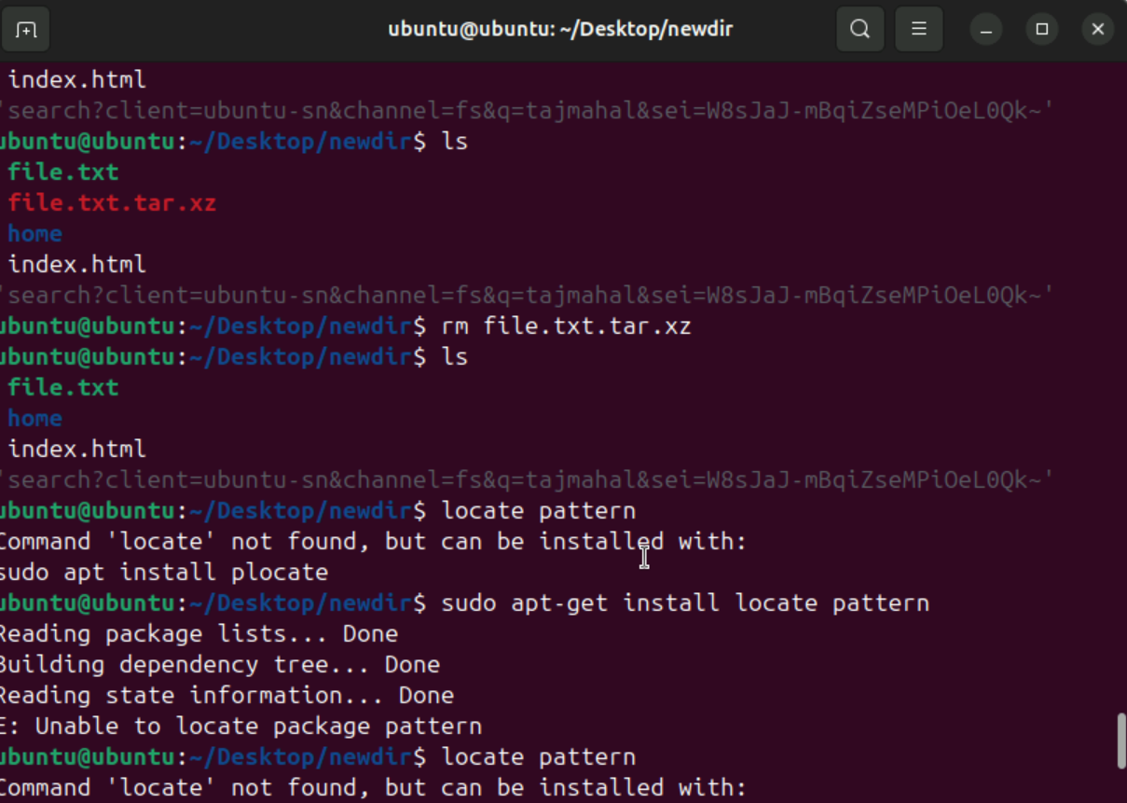

Error was the 'locate' was not found

**Troubleshoot:**

By installing the packages error was handled

1. Command: locate pattern

Locate pattern is used to  Search and print files and folders.

Error Image:

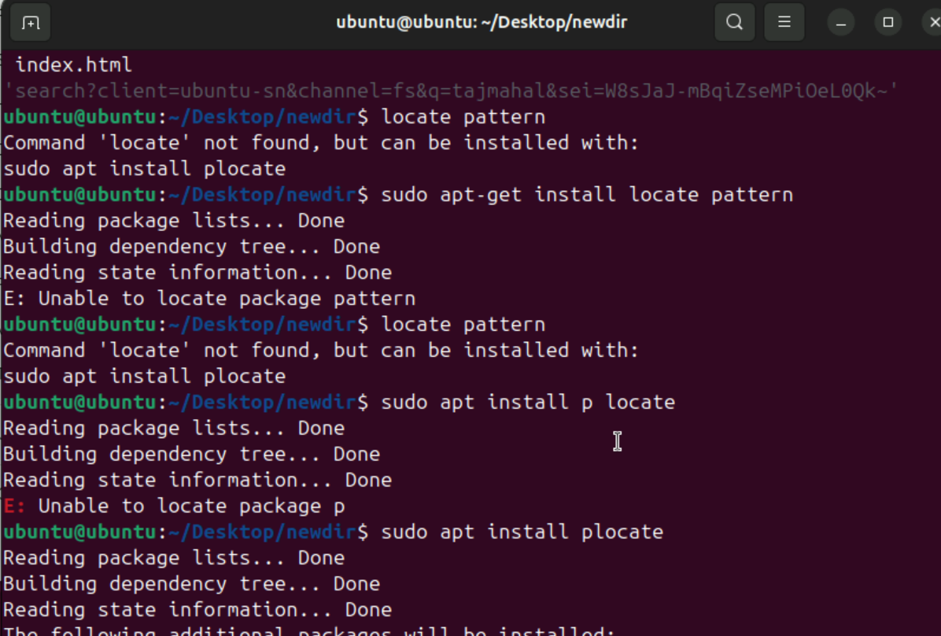

Second error was with sudo apt install package

**Troubleshooting:**

Wrong syntax used in to install the locate pattern.

Command:sudo apt install plocate.

1. Command mv

This command is used to move a file from source to destination.

Error Image:

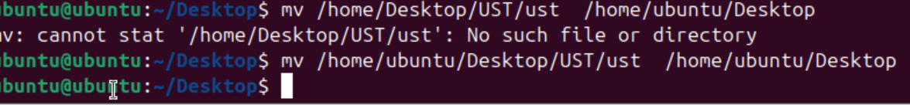

No such file or directory.

Troubleshooting:

Need to correctly mention the source and destination path.

1. Command: rmdir “directory_name”

This command is used for deleting a directory.

Error Image:



**Troubleshooting:**

Rmdir cannot remove the unempty directory

Command : rm -r “filename”

Trouble Shooting Count:

Prajwal - 3

Pradul - 2

Gayathry – 3

Pramitha - 2